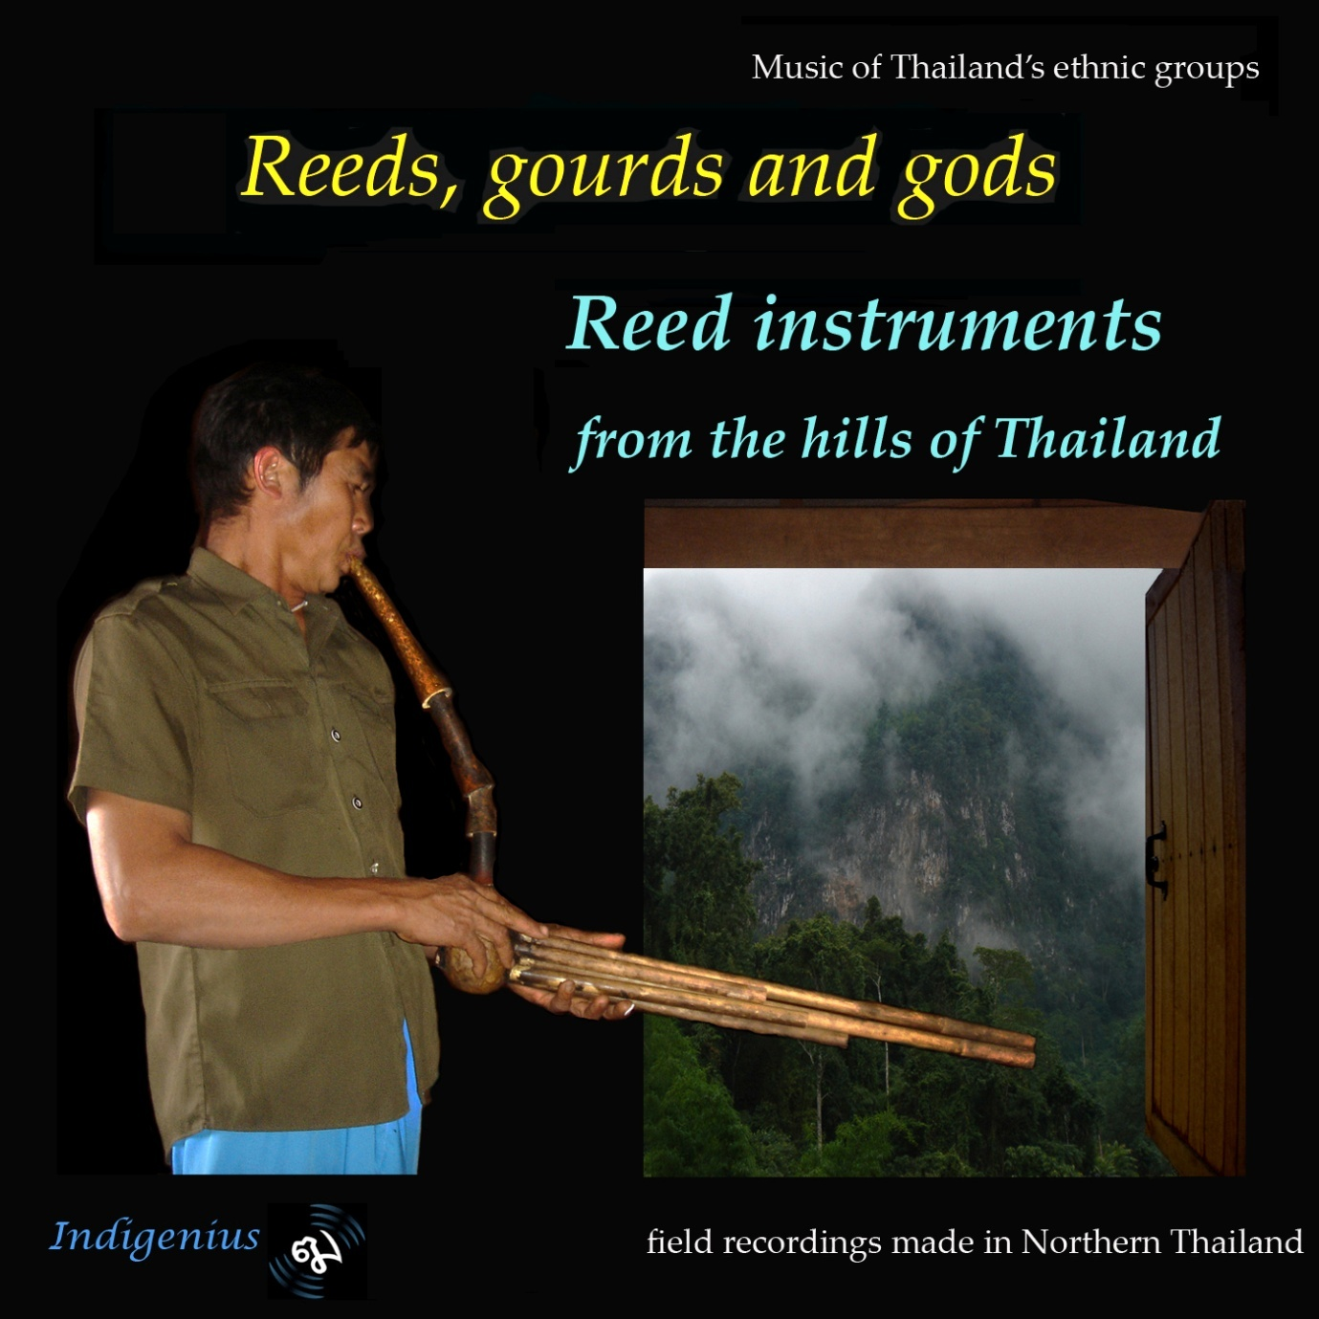
Lisu musician playing pali fulu

Track | 1 | Hmong free reed pipes (qen) Wedding tune
Track | 2 | Hmong free reed pipes (qen) New Year dance
Track | 3 | Hmong free reed pipes (qen) dance tune
Track | 4 | Hmong qen funeral music
Track | 5 | Hmong free reed pipe (traa nplai)
Track | 6 | Hmong bass free reed pipe(traa nplai)
Track | 7 | Akha free reed pipes (la yae)
Track | 8 | Karen free reed horn (kwae) with percussion
Track | 9 | Lisu free reed pipes (pali fulu)
Track | 10 | Lisu large pali fulu
Track | 11 | Lisu and Lahu tenor free reed pipes (fulu lae lae, tolaemu)
Track | 12 | Lahu and Lisu bass free reed pipes (naw seu, fulu na o)
Track | 13 | Lahu free reed pipes (naw julae) dance tunes
Track | 14 | Lahu free reed pipes (naw julae) courting tunes
Track | 15 | Lahu Contrabass Free Reed Pipes (nawkuma)
Track | 16 | Khamu free reed pipes (sngkuul) teum music
Track | 17 | Khamu idioglottal reed pipe pii koon rook
Track | 18 | Mlabri free reed pipes (khaen)
Track | 19 | Tai Neua hulusi
Track | 20 | Palaung hulusi (waou)
Track | 21 | Mien shawm (dzat) with percussion Wedding music
Track | 22 | Lua leaf
Track | 23 | Kachin shawm (Pahke) with percussion Manau festival

Reeds, gourds and gods
Reed instruments from the hills of Northern Thailand
The indigenous people of Southeast Asia possess a remarkable array of reed instruments. Most spectacular are the free reed instruments with pipes ranging from a few centimetres in two two metres in length. Double reed instruments are also common in several cultures as well as idioglottal clarinets, where the reed is cut from the body of the instrument itself. This album, which covers the music of 12 ethnic groups , provides examples of singe free reed pipes played by the Hmong, Karen horns, instruments consisting of a melody pipe and drones played by the Palaung and Tai Neua and truly polyphonic instruments with multiple pipes played by the Hmong, Lisu, Akha, Lahu, Mlabri and Khamu. It also features shawms played by the Kahin and Mien groups as well as an idioglottal clarinet of the Khamu and, finally a simple mango leaf played by a Lua virtuoso.
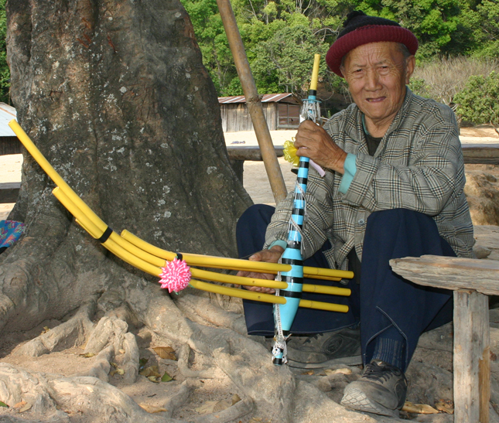
Track 1 Hmong free reed pipes (qen) Wedding tune
The Hmong people probably originated in Tibet, Siberia or Mongolia, spread into China and from there to Vietnam, Laos and Northern Thailand.
The qen is in a sense an icon for Hmong culture and plays a major part in several Hmong ceremonies including weddings, New Year celebrations and funerals when it guides the soul on its journey. It is an important means of communicating with the spirit world but may also be used for example to welcome a guest or for entertainment. It is a solo instrument, played without the accompaniment either of other musical instruments or singing, although it is intermittently accompanied by drums at a funeral. It consists of a wooden wind chest with a long tapering neck ending in a mouth hole which is often covered by a removable stopper. This wooden section is made from two identical pieces of mahogany bound together with straps. The six bamboo tubes are variously curving or straight. Each has a single hole for fingering above the wind chest and a metal free reed over a hole in the pipe enclosed within the wind chest. For extra volume the lowest tube, the thickest and shortest one, often contains two or three reeds.

Track 2 Hmong free reed pipes (qen) New Year dance
Track 3 Hmong free reed pipes (qen) dance tune
Track 4 Hmong qen funeral music

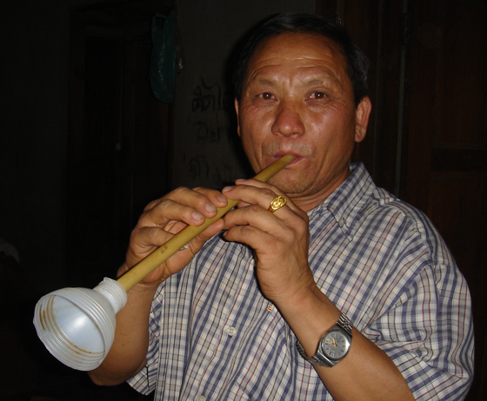
Track 5 Hmong free reed pipe (traa nplai)
This Hmong instrument, called the the taa nplai, is very similar in design to the Northern Thai pi jum. The style and manner of playing, with strong dynamic contrasts though, are quite different. The reed is sounded only by exhaling so players use circular breathing to keep a continuous flow.
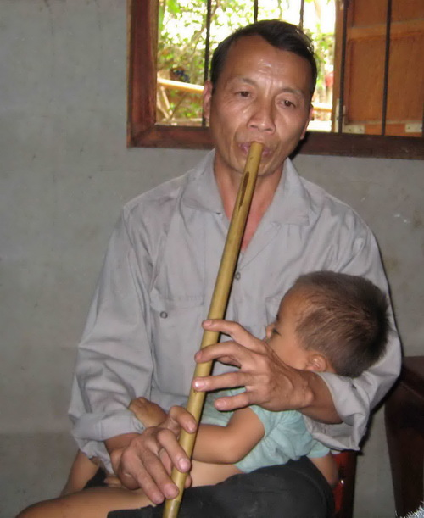
Track 6 Hmong bass free reed pipe(traa nplai)
Traa nplai are made in a variety of sizes and can have from 5 to 7 holes. They are played by using the lips to create a seal around the reed or, on smaller instruments, by inserting the top of the instrument into the mouth.
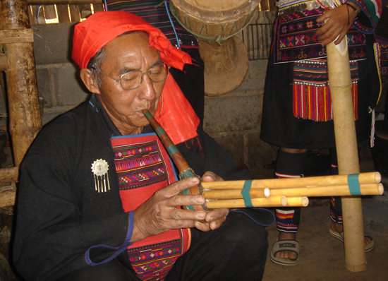
Track 7 Akha free reed pipes (la yae)
The Akha people have migrated from Tibet to China, Laos, Burma and Thailand, where they live in Chiang Mai and Chiang Rai provinces.
The Akha, Lisu and Lahu all play very similar small free reed pipes (or ‘organs’). These are used most commonly to accompany dancing but they also have a repertoire of courting music. The instruments have five pipes, each containing a free reed and with one finger hole, set in a gourd. Each pipe makes a separate note when this hole is stopped so the instrument can play chords. Free reed pipe music is therefore the most polyphonically rich of that found in the Thai ethnic groups. Players can both suck and blow (so circular breathing is not needed to keep the music flowing continuously) and bend or change notes with the thumb by stopping the hole at the bottom of each pipe. The Akha play it solo or sometiems along with percussion to accompany singing.
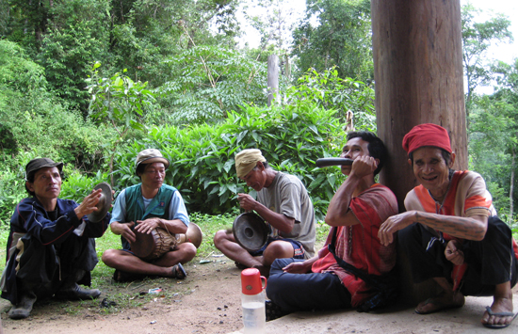
Track 8 Karen free reed horn (kwae) with percussion
The Karen peoples have since time immemorial resided in Burma and for several hundred years in North West Thailand.
Brass free reeds are also inserted into animal horns and these instruments, played notably by the Karen (kwae), Khamu and Lua have several uses. The Lua use them to call the spirits before a ceremony. With the Karen the prime function is a call to the harvest or as men were walking to the harvest at dawn, to frighten away tigers. The Karen also play them with gongs and other percussion for a type of sword dance performed on occasions such as weddings. They also enable young women to assess the strength of the player as they’re particularly hard to blow. The notes are made by alternately blowing and sucking and stopping the end of the horn with one hand. The horns can be made from a deer horn, elephant tusk or buffalo horn; the horn for people with the highest status, only allowed to leaders of sizeable communities, is made from the beak of a hornbill. Wooden horns were also used.

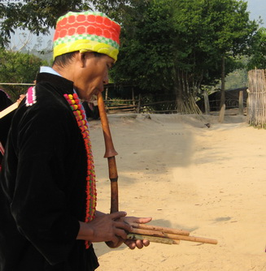
Track 9 Lisu free reed pipes (pali fulu)
The Lisu also originated in Tibet from where they migrated to the highlands of Burma’s Shan State and Yunnan Province in China, eventually spreading into Thailand and India.
The smallest Lisu free reed organ is the most popular and no Lisu festival with dancing would be complete without at least one player.
Track 10 Lisu large pali fulu
The Lisu free reed organs are made in several sizes. What distinguishes the largest from the similarly sized fulu lae lae and na o is the tuning.
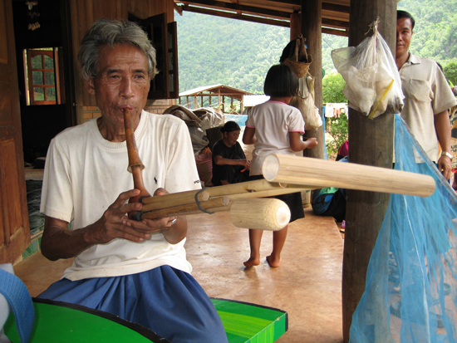
Track 11 Lisu and Lahu tenor free reed pipes (fulu lae lae, tolaemu)
The fulu lae lae and the Lahu tolaemu are tuned to a hemiphonic pentatonic scale not often found in SE Asia. The lowest pipe has no finger hole and provides a constant drone.
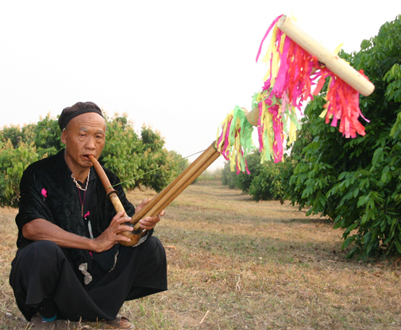
Track 12 Lahu and Lisu bass free reed pipes (naw seu, fulu na o)
The Lahu naw seu and Lisu fulu na o have 2 only pipes below the gourd and only 1 open for ornamentation/pitch change (in some all pipes are closed at the protruding end). A drone is played throughout. They are tuned to 4 note scale with octave doubling. They are harder to play than the others and also quieter than the the higher pitched instruments and consequently less popular when there are large dances. They are now mostly played by elderly men.
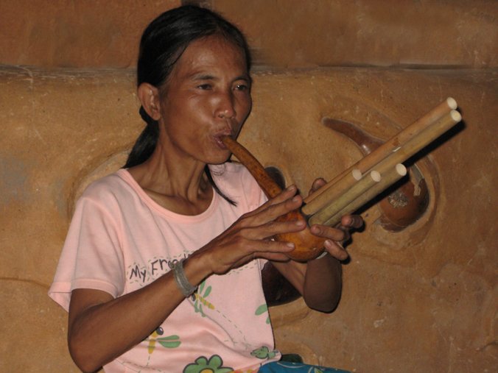
Track 13 Lahu free reed pipes (naw julae) dance tunes
Originally from Tibet, the Lahu migrated into China, the Shan states of Burma and Northern Thailand. In some ways Lahu society is more egalitarian than the others and women are not discouraged from playing musical instruments. There are considerable differences in the music of the two main subgroups, Red and Black. (Tracks 11, 12 and 15 on this album are Black Lahu; track 14 is Red Lahu).

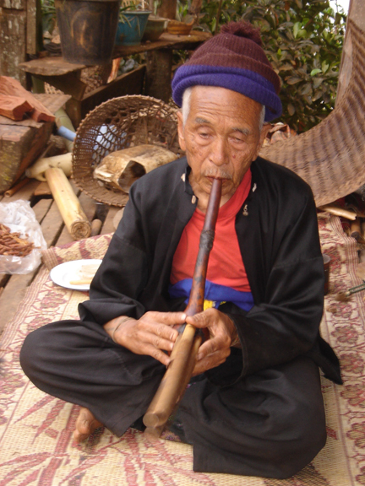

Track 14 Lahu free reed pipes (naw julae) courting tunes
The courting music played on free reed pipes is slwer than dance tunes and does not have a regular rhythm. Players can be much more expressive and use single notes as well as chords to create haunting melodies,
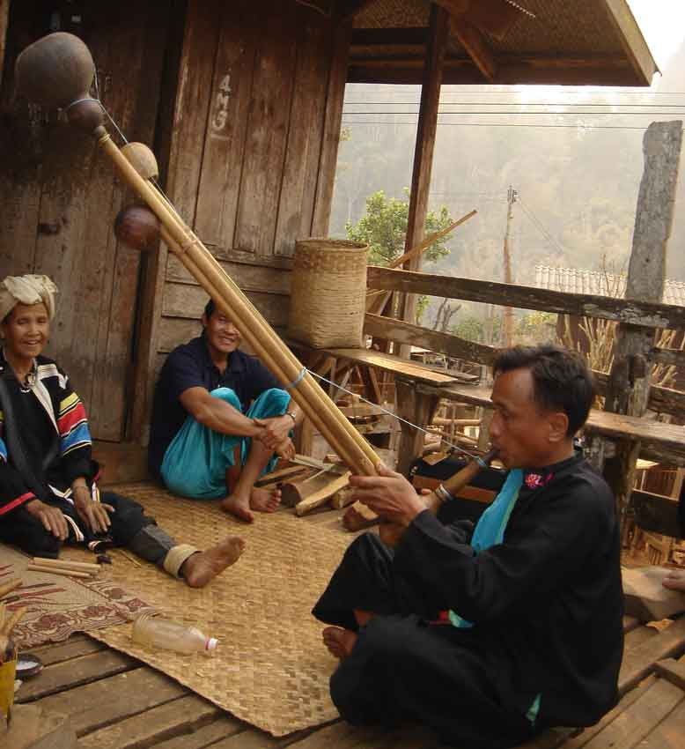
Track 15 Lahu Contrabass Free Reed Pipes (nawkuma)
The Black Lahu have a contrabass version of the free reed organ with pipes as long 2 metres, the nawkuma. In former times it was also used to accompany dancing but now it is reserved for ceremonies such as those for soul-calling. It is the most revered Lahu instrument as traditionally with a central place in spiritual life as no ceremony could start without one first calling the spirits.

Track 16 Khamu free reed pipes (sngkuul) teum music
The origins of the Khamu people are uncertain but they have lived in Yunnan, Vietnam and Laos for centuries and there are some communities in North and North East Thailand.
The Khamu use the Thai khaen, a sixteen reed bamboo mouth organ (a double row of bamboo reeds fitted into a hardwood sound box) native to the Isaan people of northeastern Thailand and Laos. The khaen has successfully made the transition from a traditional instrument to occupying an important place in modern Issan and Lao music.
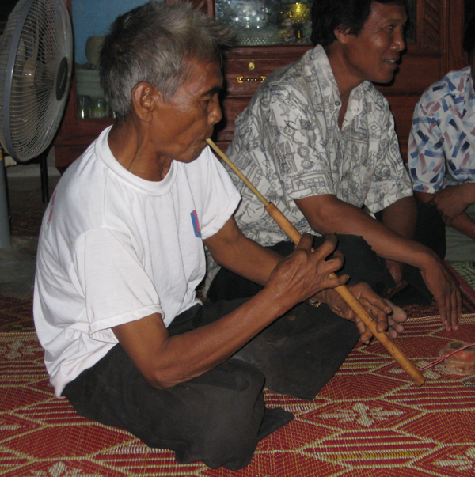
Track 17 Khamu idioglottal reed pipe pii koon rook
The Khamu have several forms of idioglottal clarinets; usually the reed is in a separate thin tube inserted into the top of the body. Sometimes several tubes of increasing diameter are joined together to make a conical shape. Another form is made from long thin rice stalks.
Track 18 Mlabri free reed pipes (khaen)
As the most ‘primitive’ ethnic group living in Thailand the Mlabri do not have a musical tradition of much note. They use simple whistles to call other group members when in the forest. They also have songs for occasions like receiving a guest and accompany the music with bamboo sticks. Some have now been drawn into other Thai and hilltribe communities and are influenced by the music of north east Thailand and Laos. The music here is a good example of how traditional music evolves. The khaen player left the forest to work in a village with a Hmong family near the Laotian border. There he heard Lao radio and was captivated by the sound of the khaen- so his Hmong emplyer bought him one.
Track 19 Tai Neua hulusi
This instrument has a single pipe with finger holes and one or more drones set in a gourd wind chamber, each pipe containing a free reed inside the gourd. It is played by the Palaung, Shan, Wa, Tai Neua and Kachin and is known in China as hulusi. It is used for both for courting and relaxing, for example after a hard day in the fields. It is almost exclusively a solo instrument but the Palaung sometimes play it with a lute.
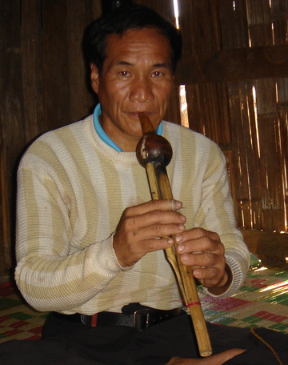
Track 20 Palaung hulusi (waou)
The Palaung originate from the Shan states of Burma, where most still live, and are particularly associated with tea-growing. There are several small communities in Chiang Mai province. see also notes on Track 19
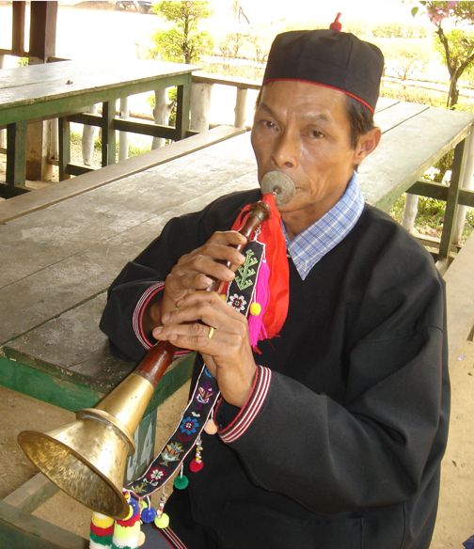
Track 21 Mien shawm (dzat) with percussion Wedding music
Originally from China, where many still live, the Mien (or Yao) are also found in Vietnam and Laos and in Northern Thailand, especially Chiang Rai province.
Two types of shawm are found in the region. The first is an instrument with detached brass bell the same as is played in China, Burma and by the Northern Thai. This is the most significant instrument for the Mien and figures prominently in all ceremonies especially weddings and funerals, normally accompanied by percussion.

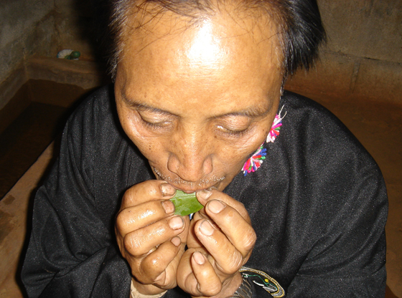

Track 22 Lua leaf
The Lua most probably originate from the Golden Triangle area and now live in scattered villages in North and North west Thailand.
In nearly all ethnic groups it is traditional to play tunes on a leaf- often a mango leaf, sometimes peach. They were often used to call friends or family while in the forest or for courting; the Lua have incorporated it into string ensembles.

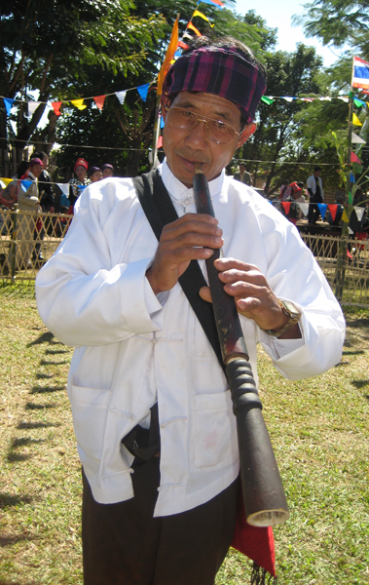
Track 23 Kachin shawm (Pahke) with percussion Manau festival
Kachin peoples migrated from areas close to Tibet and now occupy a state in Northern Burma. A small group (of Jingpo Kachin) have established a village in Chiang Mai province.
The other type of shawm, played by the Kachin, is longer and made from one single piece of wood with an integral bell, like instruments found in Western Asia. It is accompanied by percussion at festivals like the Manau festival.

Recordings by Sunthorn Yipa and John Moore.
Production by John Moore
Indigenius recordings 2009

