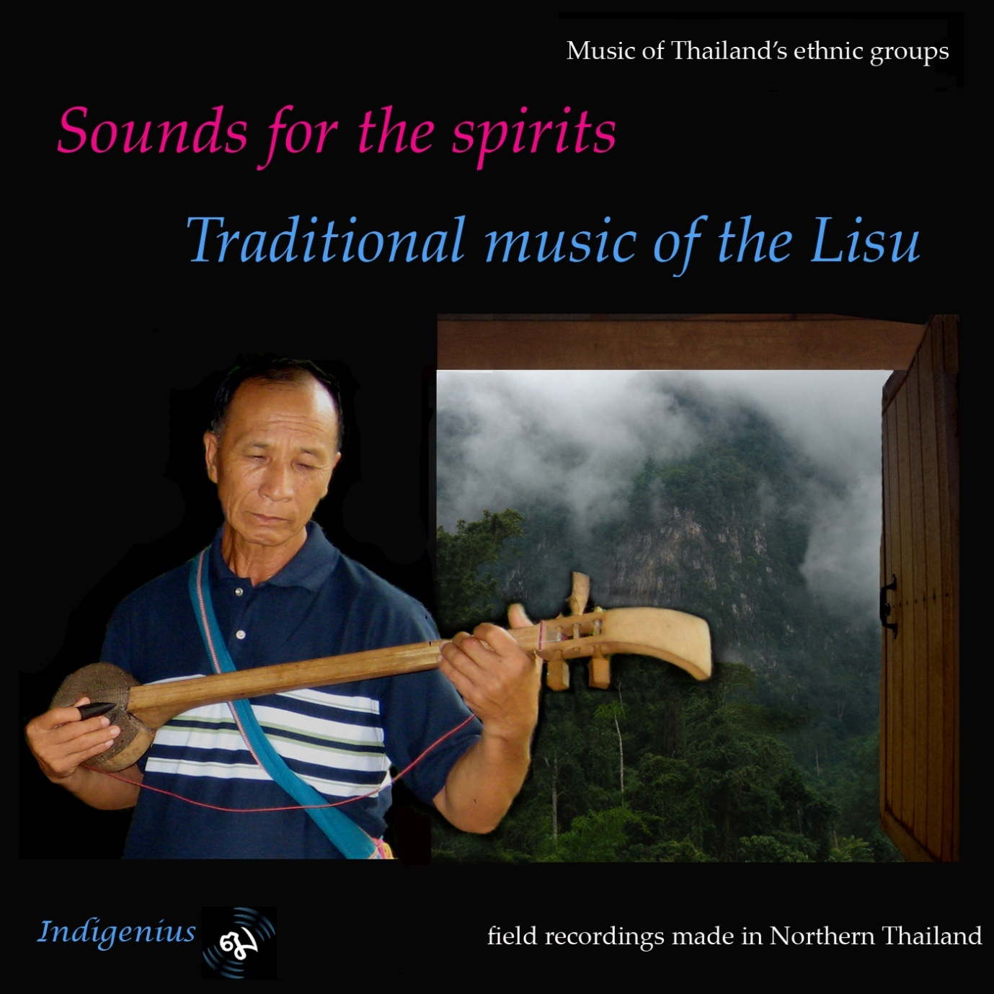
Lisu musician playing tseubeu

Track list
Track | 1 | Soul-Calling Ceremony
Track | 2 | New Year Dance Tunes For Free Reed Pipes (Pali Fulu)
Track | 3 | Courting Duet
Track | 4 | Dance Tunes For Banjo (Tseubeu)
Track | 5 | Dance Tunes For Large Reed Pipes (Fulu Lae Lae)
Track | 6 | New Year Song Accompanied By Banjo
Track | 7 | Dance Tune For Free Reed Pipes And Banjo
Track | 8 | Healing Ceremony
Track | 9 | Courting Tune For Central Embouchure Overtone Flute (Pilu)
Track | 10 | Dance Tunes For Banjo
Track | 11 | Dance Tunes For Free Reed Pipes And Banjo
Track | 12 | Ceremony To Honour The Spirits
Track | 13 | Dance Tunes For Bass Free Reed Pipes (Fulu Na O)
Track | 14 | New Year Dances With Harmonica
Track | 15 | New Year Song Accompanied By Banjo
Track | 16 | Courting Tune For Flute
Track | 17 | Courting Tunes For Free Reed Pipes
Track | 18 | Courting Song Sung By Woman
Track | 19 | Courting Song Sung By Man
Track | 20 | Dance Tunes For Banjo
Track | 21 | Dance Tunes For Flute
Track | 22 | Dance Tunes Played On Large Free Reed Pipes (Pali Fulu)

Lisu music is performed to an unseen audience: even the most raucous dance music is held to please the spirits. In their numerous ceremonies and private music-making, the Lisu express their respect for the other world as well as for their traditional beliefs and values.
Originally from Tibet, the Lisu migrated into the highlands of Burma’s Shan State and Yunnan Province in China, eventually spreading into Thailand and India.
Many in Thailand have arrived from isolated communities in Burma and their differing ancestry and geographical background has led to variations in their music.

Track 1 Soul-calling ceremony
In this ceremony, which may last several hours, a chorus of villagers responds to each verse sung by the lead singer. Soul-calling ceremonies are held when someone has suffered sickness or misfortune in the belief that one of a person’s souls has wandered and needs to be recalled to restore the body to health. The free meter of Lisu vocal music allows for long, extended notes with elaborate ornamentation

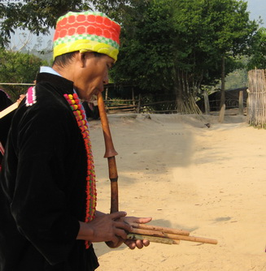

Track 2 New Year Dance tunes for free reed pipes (pali fulu)
The most significant event of the Lisu year is the New Year Festival which is held in two parts coinciding with the Chinese New Year. Whole villages join in the dancing, young and old (though it is especially an opportunity for young men and women to meet), moving from house to house throughout the night. Several instruments may accompany the dancing, the most common being the small free reed pipes (pali fulu). Five bamboo pipes are set in a gourd wind chamber, each one containing a free reed and sounded when a hole on the side is stopped. Normally two or more pipes are sounded simultaneously, creating a rich and rhythmic polyphony.
Track 3 Courting duet
Antiphonal courting songs form a major part of the Lisu vocal repertoire. Traditionally, they were sung by groups of young men and women in search of a mate; nowadays these songs are sung on other occasions and for entertainment. Singers draw on a corpus of stock verses and themes around which they improvise to fit the occasion.
Track 4 Dance tunes for banjo (tseubeu)
The other most common instrument that accompanies dancing is the tseubeu, a long-necked fretless three string lute that has a soundboard made from python on monitor lizard skin. It is plucked with a plectrum, traditionally made of the tip of a buffalo horn.
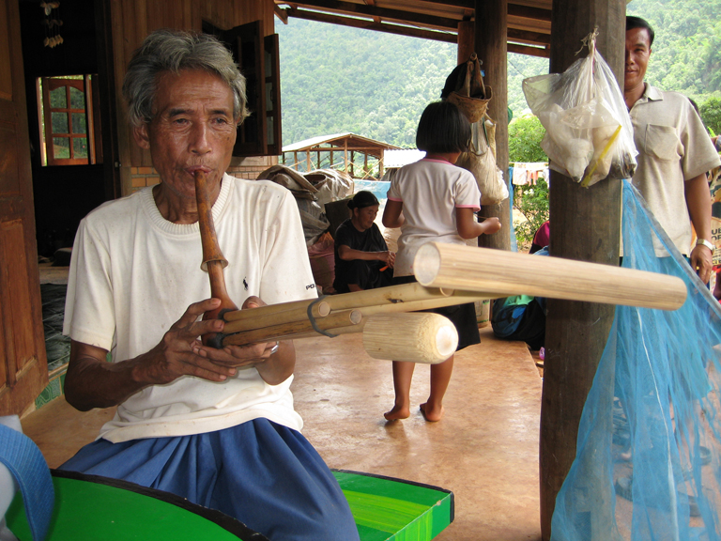

Track 5 Dance tunes for large reed pipes (fulu lae lae)
The fulu lae lae is larger than the more common pali fulu and is tuned to a hemiphonic pentatonic scale not often found in SE Asia. The lowest pipe has no finger hole and provides a constant drone.

Track 6 New Year Song accompanied by banjo
Lisu vocal music is normally unaccompanied but on occasions singers may be joined by a tseubeu player.
Track 7 Dance tune for free reed pipes and banjo
Around the New Year groups of villages will often join together for two or three days of dancing and celebration, providing the opportunity for musicians to play together in a spontaneous jam session.
Track 8 Healing ceremony
This ceremony was held or an elderly lady who had been in poor health for some time. Her family engaged some of the most well-known singers of the area to lead the singing. As in Track 1, the lead singer is followed in response by the other participants in chorus.
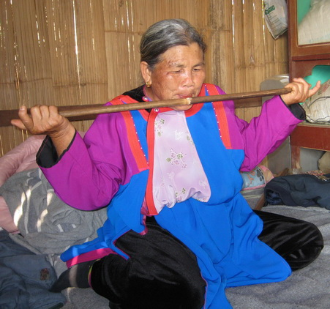

Track 9 Courting tune for central embouchure overtone flute (pilu)
The pilu is made from a long thin tube of bamboo. A square notch is cut one inch off centre and the instrument is side blown. The player uses thumbs or fingers to stop one or both of the two ends of the flute as well as playing it unstopped. Traditionally young men and especially women would use it to attract interest in the opposite sex and conduct a secret dialogue. Here, a man player is followed by a woman with a more breathy timbre.
Track 10 Dance tunes for banjo
The tuning of the tseubeu varies according to the music to be played. In this track we hear different styles of playing from a number of Lisu subgroups. During the long dances players alternate but each player may play for up to three hours non stop.

Track 11 Dance tunes for free reed pipes and banjo
Dance music maintains a steady beat to which the dancers either move round in a circle or, as here, in rows. The two instruments play almost independently with the pali fulu player making continual slight variations of harmonies on the same tune.
Track 12 Ceremony to honour the spirits
Each village and household has supernatural forces associated with it and people gather together frequently to pay their respects to the spirits of the ancestors and nature. In this ceremony, the shaman’s chanting is accompanied by the beating of hollow bamboo tubes.
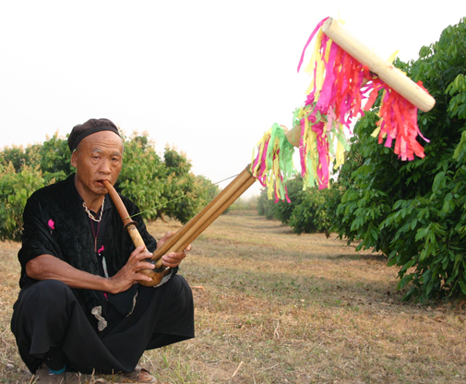
Track 13 Dance tunes for bass free reed pipes (fulu na o)
The fulu na o is the largest free reed pipe used by the Lisu. Although it is still used to accompany dancing, it is less common than the other members of the family partly as it takesmore strength to blow but also because it’s quiet gruff tones are les easily heard against the shouts and stamping of the dancers.
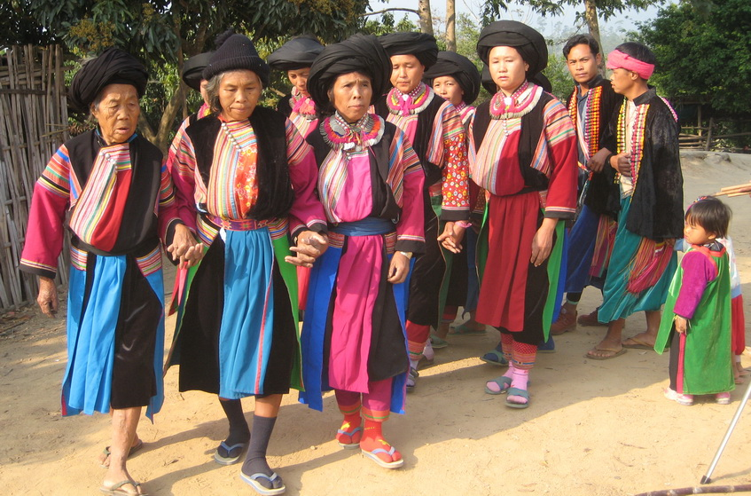
Track 14 New Year dances Black Lisu style
Black Lisu dancers move round in rows like the spokes of a wheel rather than in a circle, with the musicians leading the way. In this track we hear first a harmonica player who is then joined by pali fulu and tseubeu.

Track 15 New Year Song accompanied by banjo
The musicians are the same as in track 6.
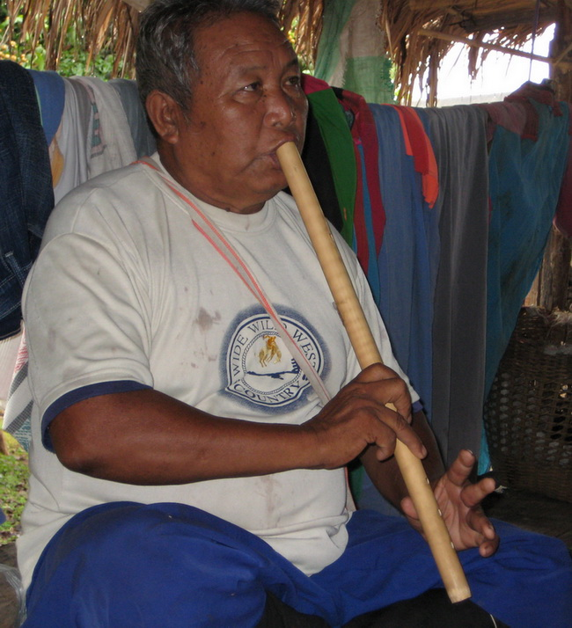
Track 16 Courting tune for flute
The flute used here is a six hole duct flute, most commonly used to accompany the dances but also, as here, used to improvise courting tunes.
Track 17 Courting tune for free reed pipes
Courting music exploits the free reed pipes’ ability to weave a pattern of gentle harmonies. The old man who played here recalled the days of his youth when his prowess on the instrument would gain the admiration of many a young woman.
Track 18 Courting song sung by woman
Although most Lisu courting music follows a call and response pattern with verses of equivalent length, the style of singing heard here (originating from a more isolated Burmese group) allows the singer more scope to develop and extended theme over a series of verses.

Track 19 Courting song sung by man
The response to the song sung in Track 18.

Track 20 Dance tunes for banjo
Some more examples of tunes from the tsebeu player’s repertoire- an accomplished player would normally have a body of 20 to 30 tunes to draw on.

Track 21 Dance tunes for flute
The flute used is the same type as in Track 16.

Track 22 Dance tunes played on large free reed pipes (pali fulu)
The instrument used here is larger than the normal pali fulu but does not have the tuning of the fulu lae lae or na o.

Recordings by Sunthorn Yipa and John Moore.
Production by John Moore
Indigenius recordings 2009

